SERVER SIDE SMALL TEST 1

VERSION A

Your name:

**Question 1 [4 poinst]**

Encircle the ONE correct statement:

1. A pure function can read a variable from the global scope
2. A pure function can return null
3. A pure function can call *unpure* functions
4. A pure function can modify the elements in the provided array argument

*Alle punten als het goede antwoord is geselecteerd.*

*Anders 0.*

# Question 2 [15 points]

For each code snippet below, encircle the correct output on the console.

console.log(x);

var x = 10;

### Your Answer:

|  |  |  |
| --- | --- | --- |
| 10 | undefined | An Error |

console.log(x);

let x = 10;

### Your Answer:

|  |  |  |
| --- | --- | --- |
| 10 | undefined | An Error |

const check = true;

if (check) {

let x = 10;

}

console.log(x);

### Your Answer:

|  |  |  |
| --- | --- | --- |
| 10 | undefined | An Error |

for (var i = 0; i < 11; i++) {

var x = i;

}

console.log(x);

### Your Answer:

|  |  |  |
| --- | --- | --- |
| 10 | undefined | An Error |

function setX(value) {

var x = value;

}

setX(10);

console.log(x);

### Your Answer:

|  |  |  |
| --- | --- | --- |
| 10 | undefined | An Error |

*3 punten voor elk correct geselecteerd antwoord*

# Question 3 [10 points]

Encircle the ***two*** code snippets that would produce an error (if you'd run them).

const list = [1, 2, 3];

list.push('hi');

const list = [1, 2, 3];

list = 10;

const list = [1, 2, 3];

list[2] = 4;

const list = [1, 2, 3];

list = [5, 6];

const list = [1, 2, 3];

console.log(list);

*4 punten als er één antwoord correct geselecteerd is.*

*10 punten als er twee antwoorden correct zijn.*

# Question 4 [40 points]

Given the following code:

|  |  |
| --- | --- |
| 01  02  03  04  05  06  07  08  09  10  11  12  13  14  15  16  17 | const execute = (nrTimes, func) => {  var person = {  name: 'han',  number: 21  };  for (var i = 0; i < nrTimes; i++) {  func(person.name);  }  }  const n = 2;  const sayHiTo = (name) => {  console.log(`Hi ${name}`);  }  execute(n, sayHiTo); |

Complete the memory model diagram on the next page when the program is executing the function execute on line 17 and inside execute, the function func on line 7 is currently being executed. The value of i is currently equal to 1.

### Remarks

* You don’t have to give the stack frames and heap objects a name. This means that you can leave the gray area of all containers in the diagram empty.
* You can leave boxes you don’t need empty.

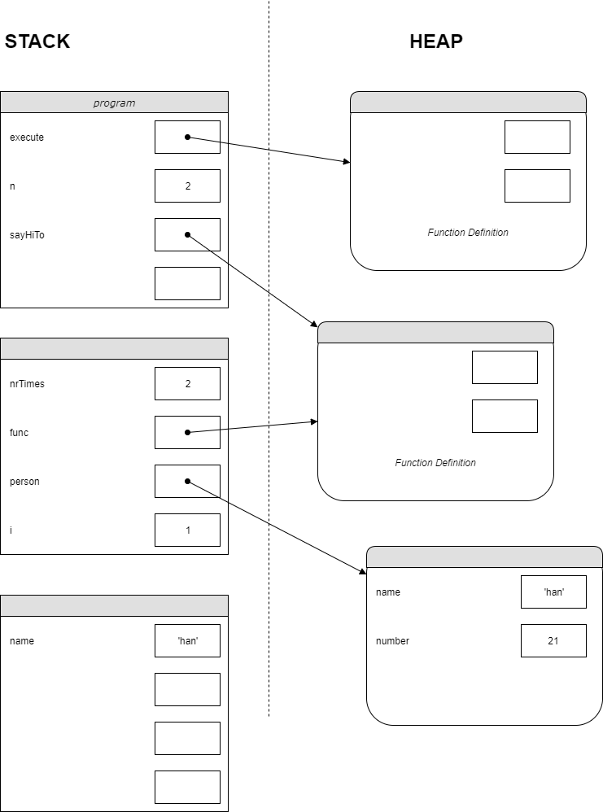

*Er moeten in totaal 10 variabelen ingevuld worden*

*Geef 4 punten voor elke variabele die correct is:*

* *2 punten als de naam en waarde correct*
* *2 punten als de variabele in het juiste blok staat*

*Het woord Function Definition levert zelf geen punten op, maar gebruik dit om te controleren of de pijl correct getrokken is en of name en number in in het juiste blok staan (ze mogen niet in een blok met function definition staan)..*

*Ook goed is uitgeschreven functie-code staat, of “function code” ipv “function definition”.*

*De objecten op de Heap zijn inwisselbaar, maar de stack frames niet*

*Een stippelijn van een function block op de Heap naar een stack Frame mag je negeren. De stippellijn verbind het stack frame met de functie die uitgevoerd wordt.*

# Question 5 [10 points]

Given the following code:

const getValidNumber = (number) => {

if (number === null) {

throw new Error('Not Valid');

}

return number;

}

const printNumbers = (list) => {

for (let i = 0; i < list.length; i++) {

console.log(getValidNumber(list[i]));

}

}

try {

printNumbers([25.5, null, 10]);

} catch (err) {

console.log(err.message);

}

Write down the console output when program is run.

### Your Answer:

|  |
| --- |
| 25.5  Not Valid |

*5 punten per correcte regel: waarde en volgorde moeten goed zijn.*

*-5 als er een derde regel is opgenomen (bijvoorbeeld met de waarde 10)*

*Aantal punten kan nooit minder zijn dan 0*

# Question 6 [18 points]

Consider these two lines of code.

let list = ['hoi', 23, 39.5];

const x = 1;

For each expression below, encircle the answer that the expression produces.

list[list['length']]

### Your Answer:

|  |  |  |
| --- | --- | --- |
| 39.5 | undefined | An Error |

list.length

### Your Answer:

|  |  |  |
| --- | --- | --- |
| 3 | undefined | An Error |

list.0

### Your Answer:

|  |  |  |
| --- | --- | --- |
| hoi | undefined | An Error |

list[1]

### Your Answer:

|  |  |  |
| --- | --- | --- |
| 23 | undefined | An Error |

list[x]

### Your Answer:

|  |  |  |
| --- | --- | --- |
| 23 | undefined | An Error |

list.x

### Your Answer:

|  |  |  |
| --- | --- | --- |
| 23 | undefined | An Error |

*3 punten per correcte selectie*

# Question 7 [3 points]

Consider this code fragment

let animal = {

sound: 'woof'

};

let otherAnimal = animal;

otherAnimal.sound = 'meow';

console.log(animal.sound);

What is the output of console.log(animal.sound);?

### Your Answer:

|  |  |  |
| --- | --- | --- |
| woof | meow | An Error |